4 Project Plan

4.1 Processes Used

4.1.1 Weekly Meetings

Once our team was formed we had regular group meetings after the classes and during the weekends to discuss the project scenarios. We divided the tasks between the team members and set the goals for every team member. Initially we had more frequent group meetings to discuss the structure and the functionality of our language. But once we were sure what our language is going to do we started working independently and updated each other using email.

4.1.2 Group Formations

To keep every member updated major communication tool used was Yahoo Mail. We formed a plt-bdpl group on the yahoo groups which contains the major updates regarding the project. Skype and Yahoo Messanger was used for online communication and conferencing. We kept a record of “todo” list and “issues” for a language as a thread on our plt-bdpl yahoo groups and Google Code, so that everyone was aware of what new issues and challenges are coming at different stages of our project and everyone can have a thought to analyze the situation.

4.1.3 Subversion

We used TortoiseSVN, a windows based subversion client that is integrated into the Windows shell.

4.1.4 Project Management Tool

We used AceProject as a Project Management Tool for our project. AceProject has plenty of project management features such as time tracking, Gantt charts, calendars and document management. It allowed us to set up our project with multiple team members.It helped in setting the deadlines, and assigning tasks to specific users. We divided our project in four parts:- Documentation, Front End, Back End and Testing Framework. We listed out the things which are of higher priority and which were of low priority. Each group member was assigned responsibility with a due date. Once the assigned tasks were finished new sets of priorities were decided and assigned to the group members. The Gantt charts for the weekly for all phases of the projects are shown below in the form of timelines. AceProject acted as the critical tool for our project organization.

4.1.5 Iterative Process

We used iterative process in our modeling. At each stage simultenously we applied testing so that we are sure that we are moving in the right direction. We believed in testing in stages rather then building the whole and keeping the testing for the later stages. Testing played a very important role for our project. The testing was done at all the stages of our project.

4.2 Programming Style Guide

Each individual has his/her own coding style. But we did have the following rules set for ourselves that all of us tried to follow:

1. All the ANTLR grammar should be in same .g file.

2. There should be clear documentation in each part of the code so that team member apart from the programmers understand it without any difficulty.

3. Each new version should clearly accompany the changes/enhancements made from the previous version. This would later provide a good log for the project.

4. Any major changes in design, etc ANTLR rules, should be first discussed with all the team members before making any change in the code.

5. The top of every Java file should have brief comment telling about what this class does.

6. Java code should follow the Java coding standards set by the Sun Microsystems.

7. We made use of the empty constructors.

8. The comments are given in the Javadoc format.

4.3 Project Timelines and Responsibilities Assigned

4.3.1 Back End Weekly Gantt Chart

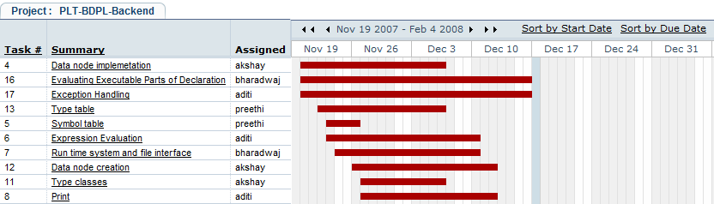

4.3.2 Front End Weekly Gantt Chart

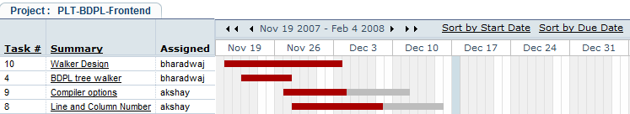

4.3.3 Test Framework Weekly Gantt Chart

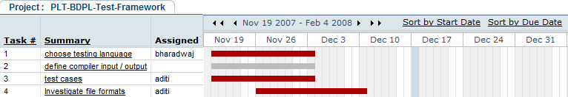

4.3.4 Documentation Weekly Gantt Chart

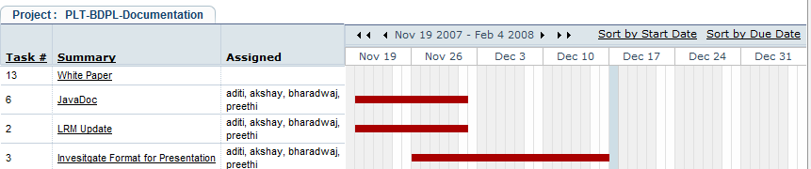
4.4 Project Log

Task | Due Date
Team Formation | 11th Sep 2007
Brainstorming the ideas | 13th Sep 2007
Exploring BDPL | 18th Sep 2007
Initial Draft for Project Proposal | 20th Sep 2007
Final Project Proposal Sudmitted | 25th Sep 2007
Discussing Finer parts of BDPL | 29th sep 2007
Exploring Nitti-Gitti’s of Language | 2nd Oct 2007
Started with Lexer and Parser | 6th Oct 2007
Finished Lexer | 12th Oct 2007
Initial Draft LRM | 16th Oct 2007
Final LRM Submitted | 18th Oct 2007
Midterm | 25th Oct 2007
Finished Parser | 1st Nov 2007
Walker Design and BDPL Tree Walker | 19th Nov 2007
Finished BDPL Tree Walker | 26th Nov 2007
Testing Language and Test Cases | 3rd Dec 2007
Final Exams | 6th Dec 2007
Investigating File Formats | 10th Dec 2007
Integration and Testing | 12th Dec 2007
Working on Final Report | 14th Dec 2007
Working on Final Presentation | 16th Dec 2007
Final Report due with Presentation | 18th Dec 2007

4.5 Development Environment and Tools Used

4.5.1 Java
Programming Language.

4.5.2 Antlr
Front End/Grammer Specifications.

4.5.3 Net Beans
Java Development Environment.

4.5.4 Ant
Build Environment

4.5.5 Google Code/Tortoise
SVN based Configuration Management

4.5.6 Google Code
Issue Submissions and Tracking

4.5.7 TCL
Test Scripting/Automation

4.5.8 AceProject
Project Planning and Tracking’

4.5.9 YDoc
Automated JavaDoc and UML class diagram generation.

